# Flashing Guideline for GPS tracker

## 1.Install Port Driver

Choose 32install or 64install according to your Windows.

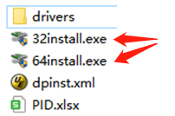

## 2.Run the flash tool ‘UpgradeDownload.exe’

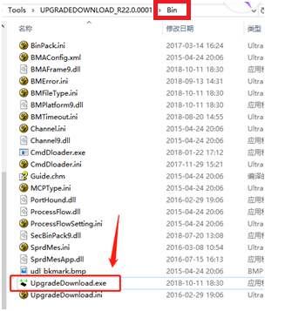

Press ‘Load packet’ then choose a ‘*.pac’ file to load the firmware.

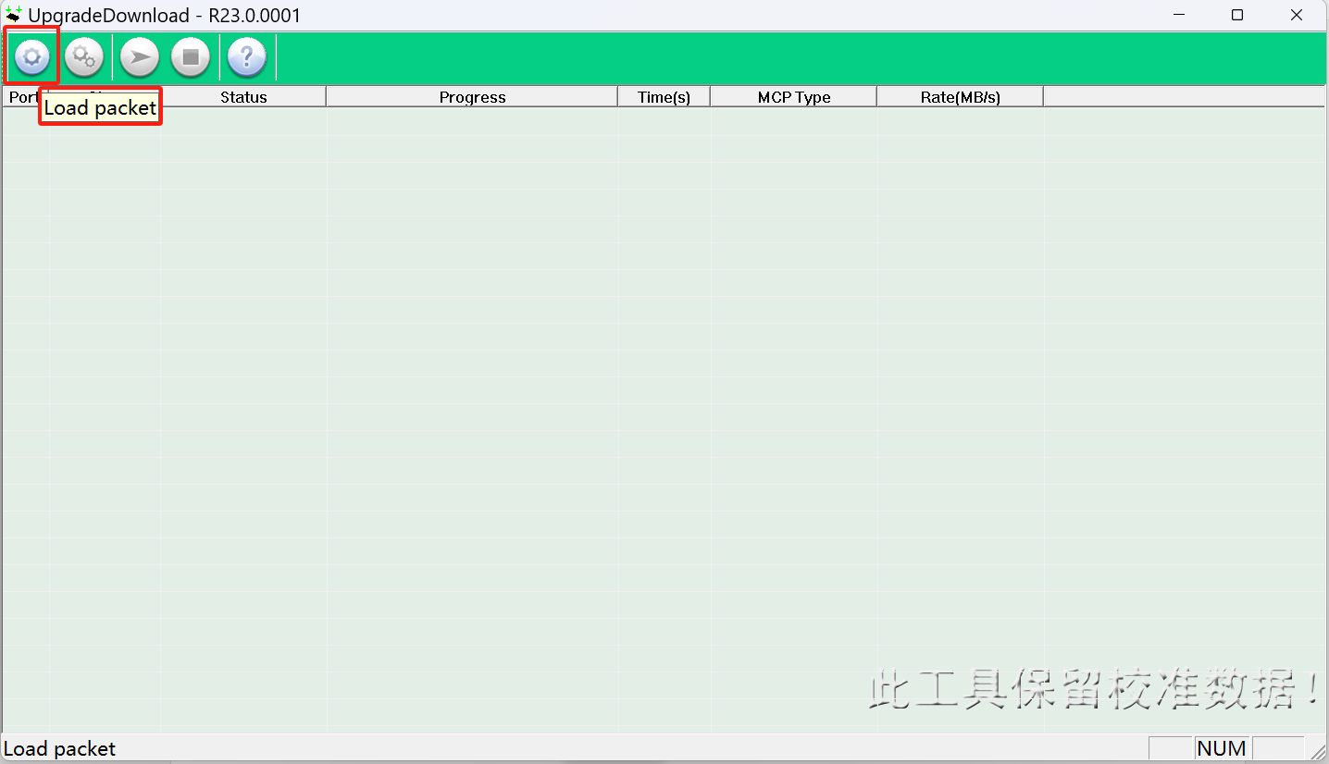

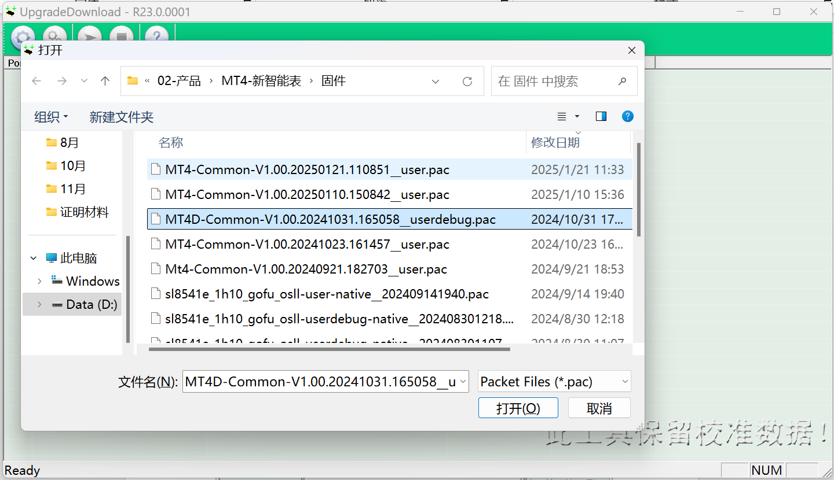

Open ‘Download settings’, choose "Power Off" in "Options" card.

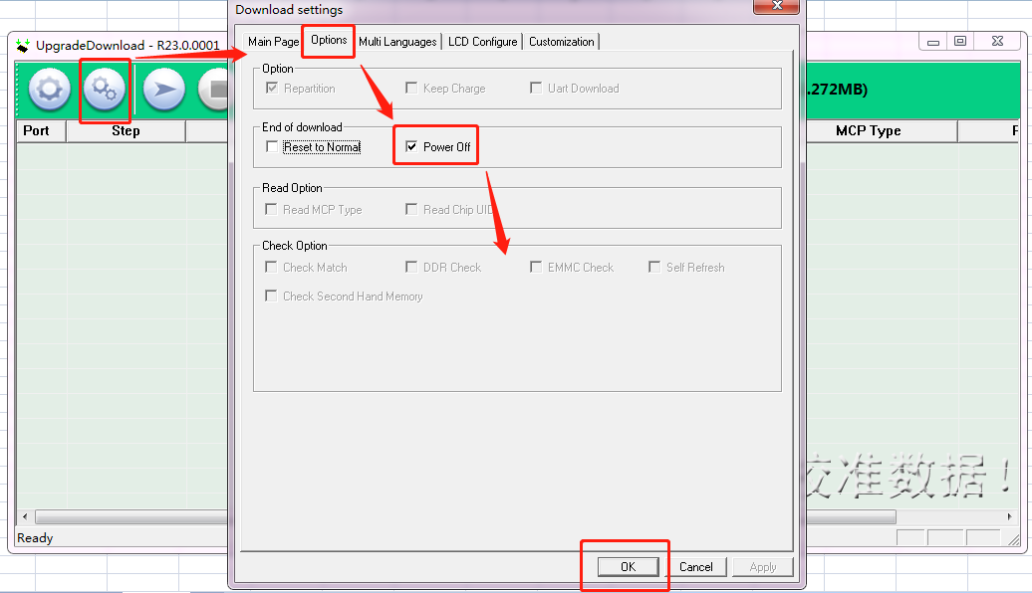

## 3.Flash the firmware to the GPS tracker

Power OFF the GPS tracker, press the start button. 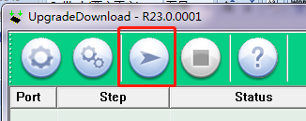

Connect the tracker to the PC with 4 /5 pins data cable. The process start will show you a blue bar.

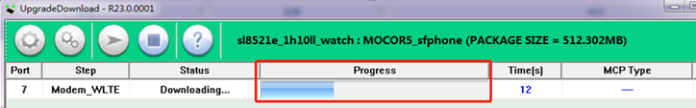

The UpgradeDownload.exe will show 'Passed' after flashing successfully.

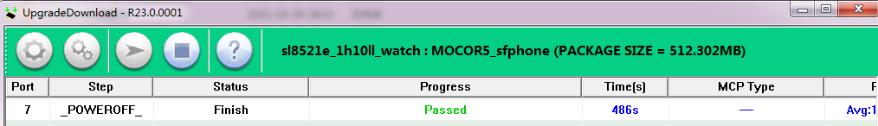

## 4.Troubleshooting

Pls open ‘Device manager’ of Windows if the flash tool doesn’t start flash firmware after connected the device. Check the Device manager shows a ‘COM & LPT’ device or not when you connect the device.

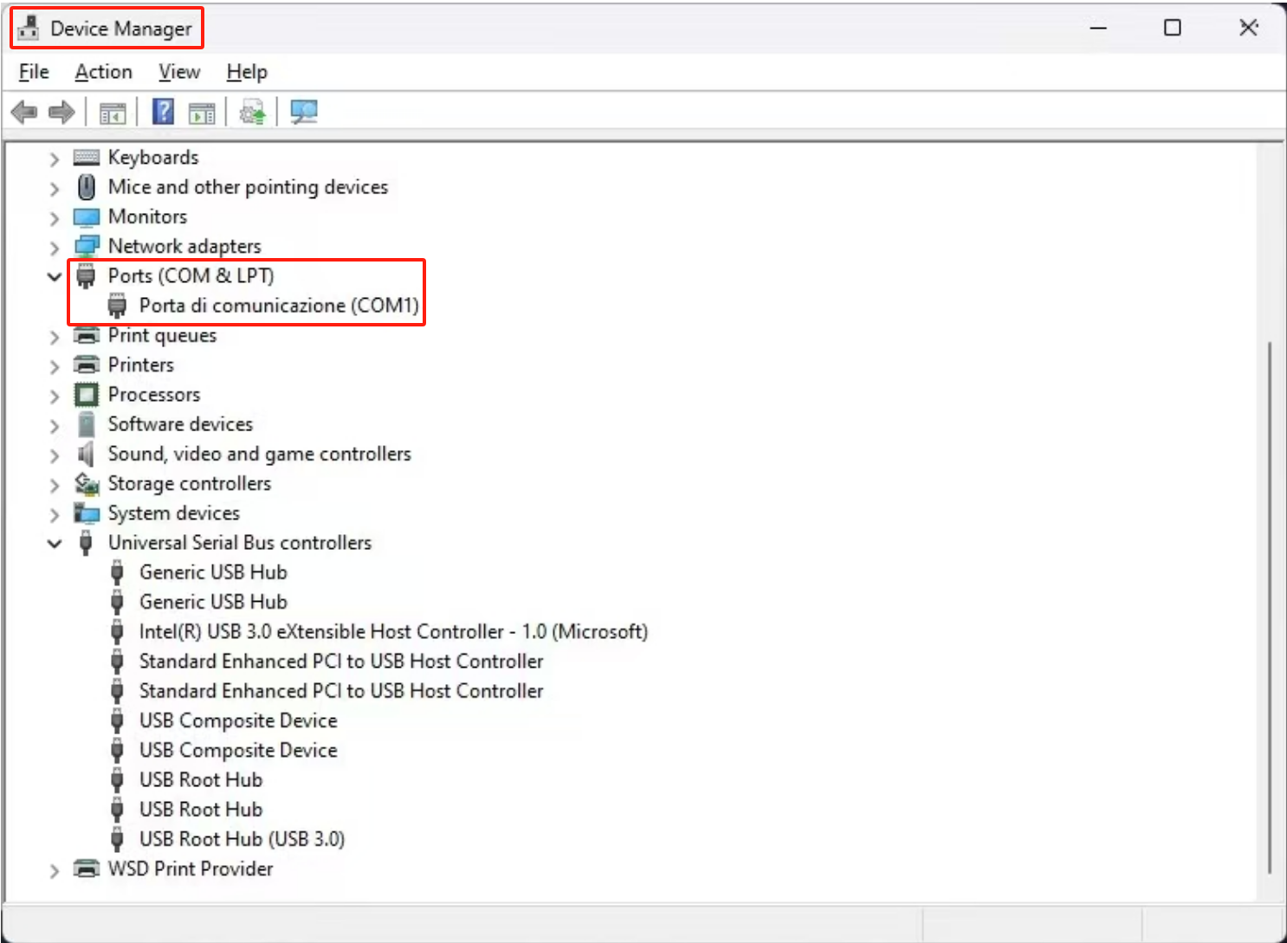

Pls install the driver again if it doesn’t show your device as a ‘COM & LPT’ device.

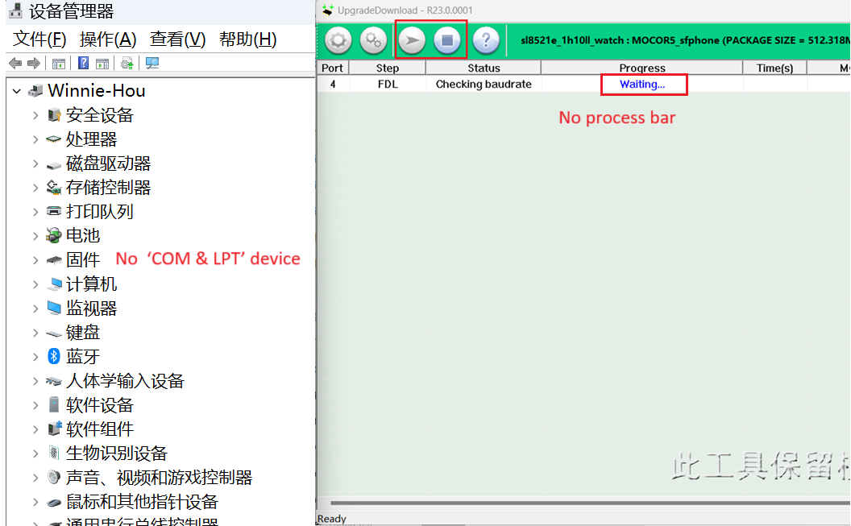

The device needs to have more than 30% battery life for flashing. A low battery level may cause the flashing process to fail. Moving the device or the data cable during the flashing process may also lead to failure. If the device becomes bricked, fails to power on, or cannot be charged, please use the charging cable to charge it and try flashing again. If the device still fails to power on after multiple attempts, please contact us.